Task2:

function task2(sentence)

{

const deletespace = sentence.trim();

const words = deletespace.split(' ');

const lastWord = words[words.length - 1];

return ` The last word is "${lastWord}" with length ${lastWord.length}.`;

}

const sentence = "Hello World";

console.log(task2(sentence));

output:

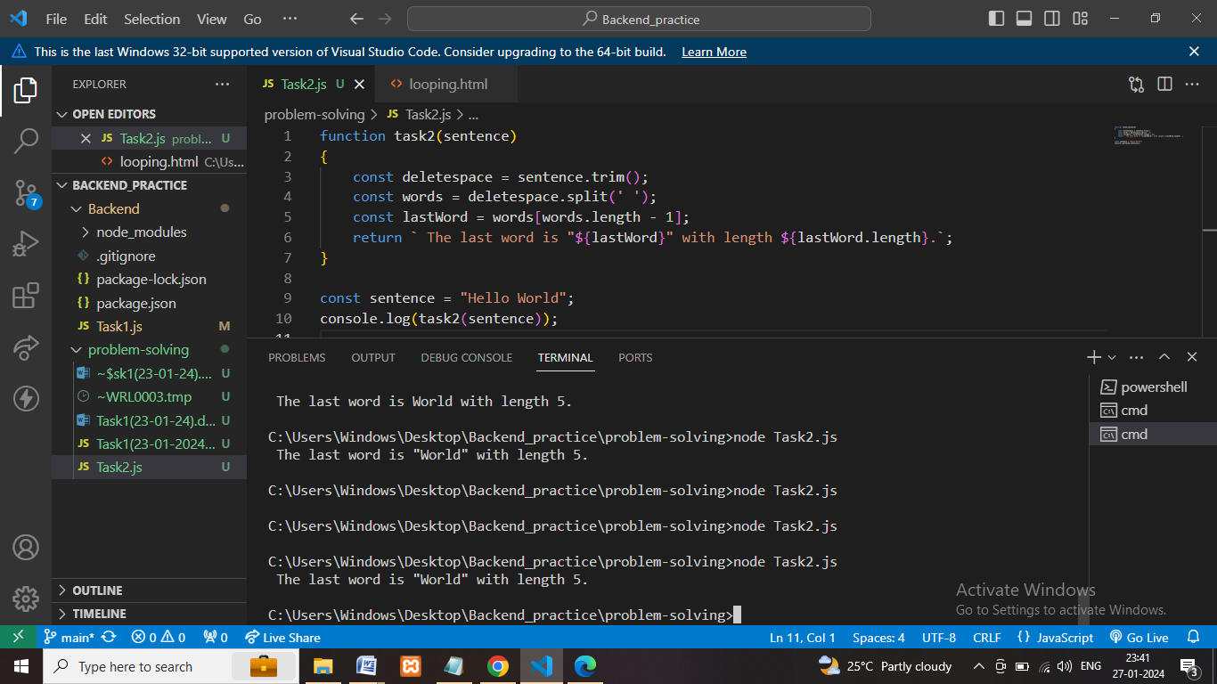

Description:

* First remove the white space in the given string.
* Next step convert the string in to array of substring.
* Next find the last word in the array length-1.

**Architecture:**

